Reference guide: Data cleaning in Python

This reference guide contains common functions and methods that data professionals use to clean data. The reference guide contains three different tables of useful tools, each grouped by cleaning category: missing data, outliers, and label encoding.

Missing data
The following pandas functions and methods are helpful when dealing with missing data.

df.info()
- Description: A DataFrame method that returns a concise summary of the dataframe, including a ‘non-null count,’ which helps you know the number of missing values
Example input:
print(df)
print()
df.info()
Example output:
planet radius_km moons
0 Mercury 2440 0
1 Venus 6052 0
2 Earth 6371 1
3 Mars 3390 2
4 Jupiter 69911 80
5 Saturn 58232 83
6 Uranus 25362 27
7 Neptune 24622 14

<class 'pandas.core.frame.DataFrame'>
RangeIndex: 8 entries, 0 to 7
Data columns (total 3 columns):
planet 8 non-null object
radius_km 8 non-null int64
moons 8 non-null int64
dtypes: int64(2), object(1)
memory usage: 272.0+ bytes

df.isna() / isnull()
- Description: A pandas function that returns a same-sized Boolean array indicating whether each value is null (you can also use pd.isnull() as an alias). Note that this function also exists as a DataFrame method.
Example input:
print(df)
print('\n After pd.isnull(): \n')

pd.isnull(df)

Example output:
Planet radius_km moons
0 Mercury 2440 NaN
1 Venus 6052 NaN
2 Earth 6371 1.0
3 Mars 3390 NaN
4 Jupiter 69911 80.0
5 Saturn 58232 83.0
6 Uranus 25362 27.0
7 Neptune 24622 14.0

After pd.isnull():

Planet radius_km moons
0 False False True
1 False False True
2 False False False
3 False False True
4 False False False
5 False False False
6 False False False
7 False False False

pd.notna() / notnull()
- Description: A pandas function that returns a same-sized Boolean array indicating whether each value is NOT null (you can also use pd.notnull() as an alias). Note that this function also exists as a DataFrame method.
Example input:
print(df)
print('\n After notnull(): \n')
pd.notnull(df)

Example output:
Planet radius_km moons
0 Mercury 2440 NaN
1 Venus 6052 NaN
2 Earth 6371 1.0
3 Mars 3390 NaN
4 Jupiter 69911 80.0
5 Saturn 58232 83.0
6 Uranus 25362 27.0
7 Neptune 24622 14.0

After notnull():

Planet radius_km moons
0 True True False
1 True True False
2 True True True
3 True True False
4 True True True
5 True True True
6 True True True
7 True True True

df.fillna()
- Description: A DataFrame method that fills in missing values using specified method
Example input:
print(df)
print('\n After fillna(): \n')

df.fillna(2)

Example output:
animal class color legs
0 cardinal Aves red NaN
1 gecko Reptilia green 4.0
2 raven Aves black NaN

After fillna():

animal class color legs
0 cardinal Aves red 2.0
1 gecko Reptilia green 4.0
2 raven Aves black 2.0

The following image shows a value of 2.3 replacing a NaN in a data cell.



df.replace()
- Description: A DataFrame method that replaces specified values with other specified values. Can also be applied to pandas Series.
Example input:
print(df)
print('\n After replace(): \n')

df.replace('Aves', 'bird')

Example output:
animal class color legs
0 cardinal Aves red 2
1 gecko Reptilia green 4
2 raven Aves black 2

After replace():

animal class color legs
0 cardinal bird red 2
1 gecko Reptilia green 4
2 raven bird black 2

The following image shows that four 2s in cells are replacing 0s.
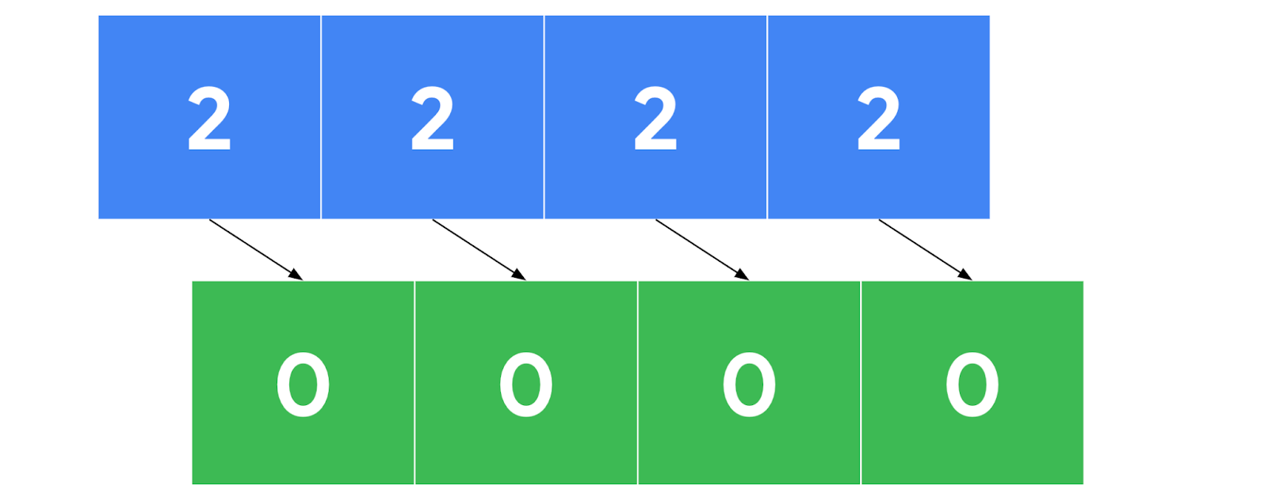

df.dropna()
- Description: A DataFrame method that removes rows or columns that contain missing values, depending on the axis you specify.
Example input:
print('Original df: \n \n', df)
print('\n After dropna(axis=0): \n')
print(df.dropna(axis=0))

print('\n After dropna(axis=1): \n')
print(df.dropna(axis=1))

Example output:
Original df:

animal class color legs
0 NaN Aves red 2
1 gecko Reptilia green 4
2 raven Aves NaN 2

After dropna(axis=0):

animal class color legs
1 gecko Reptilia green 4

After dropna(axis=1):

class legs
0 Aves 2
1 Reptilia 4
2 Aves 2

The following image shows a sequence of numbers with missing value data cells being removed.
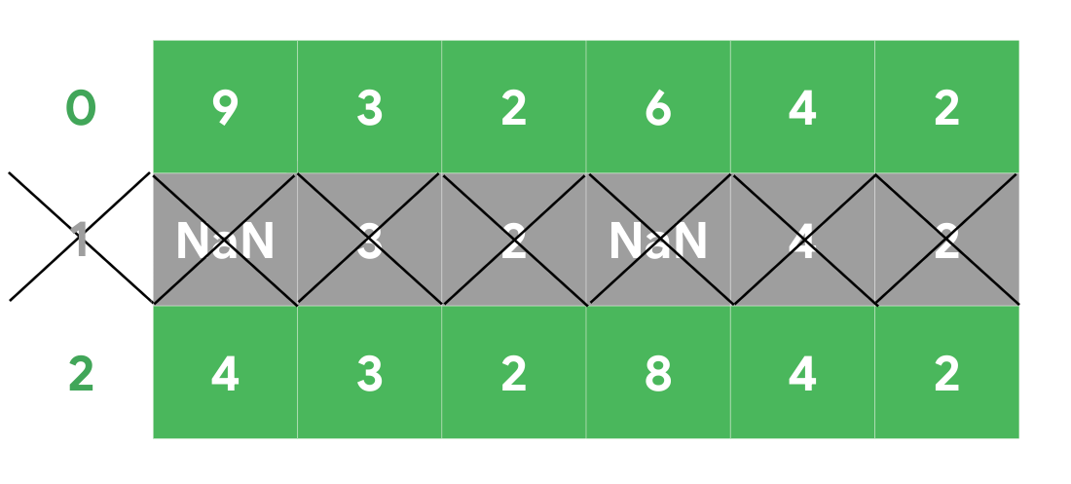

Outliers
The following tools are helpful when dealing with outliers in a dataset.

df.describe()
- Description: A DataFrame method that returns general statistics about the dataframe which can help determine outliers

Example input:
print(df)
print()
df.describe()

Example output:
planet radius_km moons
0 Mercury 2440 0
1 Venus 6052 0
2 Earth 6371 1
3 Mars 3390 2
4 Jupiter 69911 80
5 Saturn 58232 83
6 Uranus 25362 27
7 Neptune 24622 14

radius_km moons
count 8.000000 8.00000
mean 24547.500000 25.87500
std 26191.633528 35.58265
min 2440.000000 0.00000
25% 5386.500000 0.75000
50% 15496.500000 8.00000
75% 33579.500000 40.25000
max 69911.000000 83.00000

sns.boxplot()
- Description: A seaborn function that generates a box plot. Data points beyond 1.5x the interquartile range are considered outliers.
Example:
The following image shows an example graph of a box plot with min, max, lower and upper quartiles, and the median labeled.

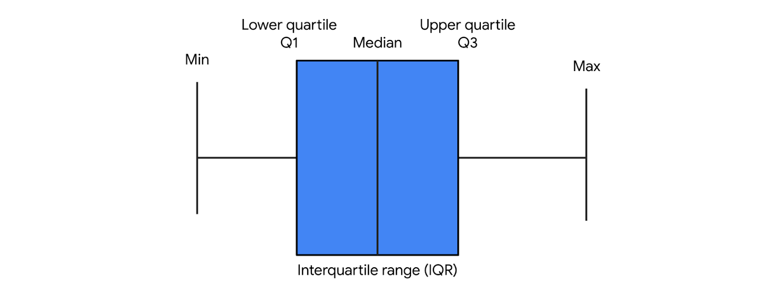

Label encoding
The following tools are helpful when performing label encoding.

df.astype()
- Description: A DataFrame method that allows you to encode its data as a specified dtype. Note that this method can also be used on Series objects.
Example input:
print(df)
print('\n Original dtypes of df: \n')

print(df.dtypes)

print('\n dtypes after casting \'class\' column as categorical: \n')

df['class'] = df['class'].astype('category')

print(df.dtypes)

Example output:
animal class color legs
0 cardinal Aves red 2
1 gecko Reptilia green 4
2 raven Aves black 2

Original dtypes of df:

animal object
class object
color object
legs int64
dtype: object

dtypes after casting 'class' column as categorical:

animal object
class category
color object
legs int64
dtype: object

Series.cat.codes
- Description: A Series attribute that returns the numeric category codes of the series

Example input:
# Cast 'class' column as categorical
df['class'] = df['class'].astype('category')

print('\n \'class\' column: \n')
print(df['class'])

print('\n Category codes of \'class\' column: \n')

df['class'].cat.codes

Example output:
'class' column:

0 Aves
1 Reptilia
2 Aves
Name: class, dtype: category
Categories (2, object): [Aves, Reptilia]

Category codes of 'class' column:

0 0
1 1
2 0
dtype: int8

get_dummies()
- Description: Converts categorical values into new binary columns—one for each different category

Example:
The following image shows a rain column with values of mild, scattered, heavy, and severe is replaced with four new binary columns—one for each category.

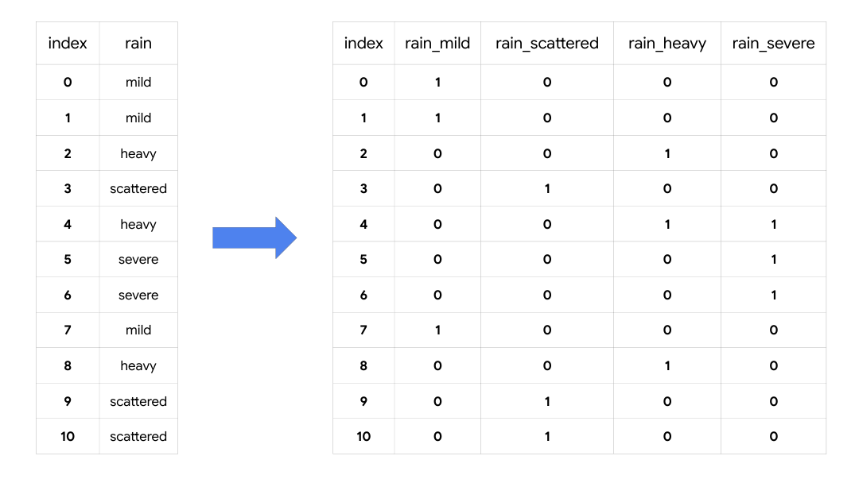

LabelEncoder()
- Description: A transformer from scikit-learn.preprocessing that encodes specified categories or labels with numeric codes. Note that when building predictive models it should only be used on target variables (i.e., y data).

Example:

It can be used to normalize labels:
from sklearn.preprocessing import LabelEncoder

# Instantiate LabelEncoder()
encoder = LabelEncoder()

data = [1, 2, 2, 6]

# Fit to the data
encoder.fit(data)

# Transform the data
transformed = encoder.transform(data)

# Reverse the transformation
inverse = encoder.inverse_transform(transformed)

print('Data =', data)
print('\n Classes: \n', encoder.classes_)
print('\n Encoded (normalized) classes: \n', transformed)
print('\n Reverse from encoded classes to original: \n', inverse)

Output:
Data = [1, 2, 2, 6]

Classes:
[1 2 6]

Encoded (normalized) classes:
[0 1 1 2]

Reverse from encoded classes to original:
[1 2 2 6]

It can be used to convert categorical labels into numeric:

from sklearn.preprocessing import LabelEncoder

# Instantiate LabelEncoder()
encoder = LabelEncoder()

data = ['paris', 'paris', 'tokyo', 'amsterdam']

# Fit to the data
encoder.fit(data)

# Transform the data
transformed = encoder.transform(data)

# New data
new_data = [0, 2, 1, 1, 2]

# Get classes of new data
inverse = encoder.inverse_transform(new_data)

print('Data =', data)
print('\n Classes: \n', list(encoder.classes_))
print('\n Encoded classes: \n', transformed)
print('\n New data =', new_data)
print('\n Convert new_data to original classes: \n', list(inverse))

Output:
Data = ['paris', 'paris', 'tokyo', 'amsterdam']

Classes:
['amsterdam', 'paris', 'tokyo']

Encoded classes:
[1 1 2 0]

New data = [0, 2, 1, 1, 2]

Convert new_data to original classes:
['amsterdam', 'tokyo', 'paris', 'paris', 'tokyo']

Key takeaways
There are many tools that data professionals can use to perform data cleaning on a wide range of data. The information you learn from missing data, outliers, and transforming categorical to numeric data will help you prepare datasets for further analysis throughout your career.

